Section A: Multiple Choice - use the answer sheet please
- Which of the following may be found in the cells of multicellular plants but NOT in the cells of multicellular animals?
J. ribosomes
K. vacuoles
L. chloroplasts
M. mitochondria
- Which of the following compounds are found only in plant cells?
J. DNA
K. cellulose
L. lipids
M. amino acids
- Which of the following is not usually found in the cytoplasm of the cell?
J. ribosomes
K. mitochondria
L. lysosomes
M. chromosomes
- Refer to the following electron micrographs that show two organelles that specialise in the transfer of energy.
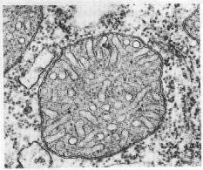
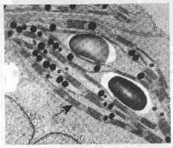

B
A

Which of the following combinations correctly identifies the two organelles and the process that occurs in Organelle B?
 | Organelle A | Organelle B | Process in Organelle B
J. | Mitochondrion | Chloroplast | Photosynthesis
K. | Chloroplast | Mitochondrion | Photosynthesis
L. | Mitochondrion | Chloroplast | Respiration
M. | Chloroplast | Mitochondrion | Respiration
- Which of the following cell structures synthesises intracellular proteins?
J. lysosomes
K. golgi apparatus
L. ribosomes
M. smooth endoplasmic reticulum
- In the fluid mosaic model, the phospholipid bilayer:
- is sandwiched between two protein layers
- has proteins embedded in it
- lies on top of a single protein
- is covered by a single protein layer
- Cell membrane carbohydrates participate in:
- transporting substances across the membrane
- cell to cell recognition
- attaching the membrane to the cytoskeleton
- attaching the membrane to the cell wall
- Many single-celled organisms such as amoeba feed by a process in which the cell membrane engulfs solid particles to form a food vacuole. This process is called:
J. phagocytosis
K. active transport
L. pinocytosis
M . osmosis
- When a cell enlarges, its:
J total surface area increases
K. volume decreases
L. surface area to volume ratio increases
M. total mass of DNA decreases
- The process in prokaryotic cell division where the DNA and its copy are divided through attachment and then growth of the plasma membrane, is called:
J. cytokinesis
K. binary fission
L. binary fusion
M. meiosis
- The main biological function of mitosis in a multicellular organism is to ensure:
J. that the sex cells contain half the number of chromosomes as that of the body cells
K. an adequate division of labour between specialised cells
L an equal distribution of hereditary material to the daughter cells.
M that all cells can reproduce, forming daughter cells

- The correct order of cells undergoing mitosis is:

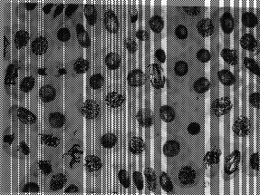

3
2

1

4
J. 3, 2, 4, 1
K. 1, 4, 2, 3
L. 1, 2, 3, 4
M. 4, 1, 3, 2
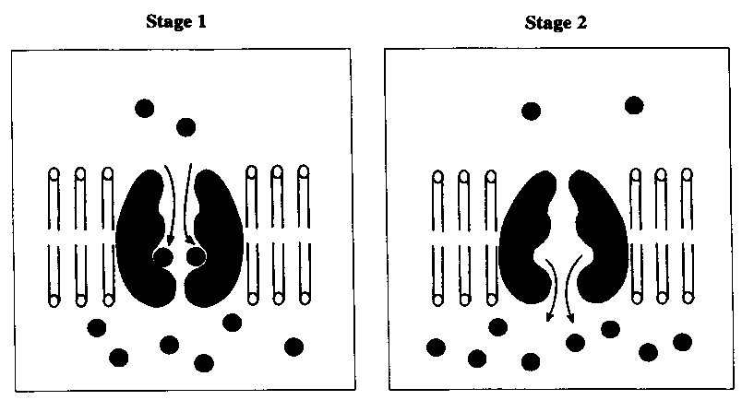
- Refer to the following diagrams, which show a process in which molecules move through a cell membrane.
The process shown in the diagrams is
- active transport
- diffusion
- osmosis
- phagocytosis
- Fresh water unicellular animals possess specialised vacuoles to remove excess water. These vacuoles contain almost pure water, with a lower concentration of dissolved substances than in the rest of the cell. The contents of the vacuoles are periodically expelled from the cell. The process involved in maintaining a low concentration of solutes in these vacuoles is
- exocytosis
- diffusion
- osmosis
- active transportation
- One method of distinguishing between a plant epidermal cell and a human liver cell is to test for the presence of
- ATP
- nucleic acids
- amino acids
- cellulose
- The following table shows the corresponding surface area and volume for each of four animal cells J, K, L, and M. From which one of the cells would carbon dioxide be removed most efficiently by diffusion, if the initial concentration gradients were the same?
Surface area (µm²) |  | Volume (µm³)
J | 2700 | 400
K | 1600 | 500
L | 3600 | 600
M | 900 | 300
- The main biological function of mitosis in a multicellular organism is to ensure
- that sex cells contain half the number of chromosomes contained by the body cells.
- an adequate division of labour between specialised cells.
- an equal distribution of hereditary material to all cells of the body.
- that all cells can reproduce, forming daughter cells.
- Which of the following is true of all cancer cells? The rapid growth and division of cancer cells is caused by:
- bacterial infection
- breakdown of normal gene regulation
- changes in the intracellular hormone receptors.
- toxic chemicals
- If cells in the process of dividing are subjected to colchicine, a drug that interferes with the functioning of the spindle apparatus, at which stage will mitosis be stopped?
- Anaphase
- Prophase
- Telophase
- Metaphase
- Which one of the following statements about the cell membrane is correct?
  - Some small molecules move passively between the phospholipid molecules.
  - Cellulose molecules act as receptors on the membrane surface.
  - Some molecules move passively through the membrane against the concentration gradient.
  - Phospholipid molecules are embedded in two layers of protein molecules.
- As a cell grows, its
- efficiency in exchanging materials across the cell membrane increases
- surface area increases.
- surface area to volume ratio increases
- Volume decreases.
- One consequence of having many small regulated steps in an energy pathway is
  - an increase in the activation energy for the pathway
  - a decrease in the amount of heat lost from the pathway
  - a decrease in the amount of ATP released from the pathway.
  - an increase in the total energy released from the pathway.
- Which one of the following characteristics must a cell have in order to be classified as a eukaryotic cell?
- A single circular chromosome in the cytoplasm
- No membrane- bound organelles
- A cytoskeleton attached to the cell membrane
- A cell wall made of cellulose.
- Carcinogens are chemicals that
- Increase the rate of cell division by causing harmful mutations
- Decrease the rate of cell division by causing beneficial mutations
- Increase the rate of cell division by causing beneficial mutations
- Decrease the rate of cell division by causing harmful mutations.
- Refer to the following diagram, which represents part of a cell membrane:
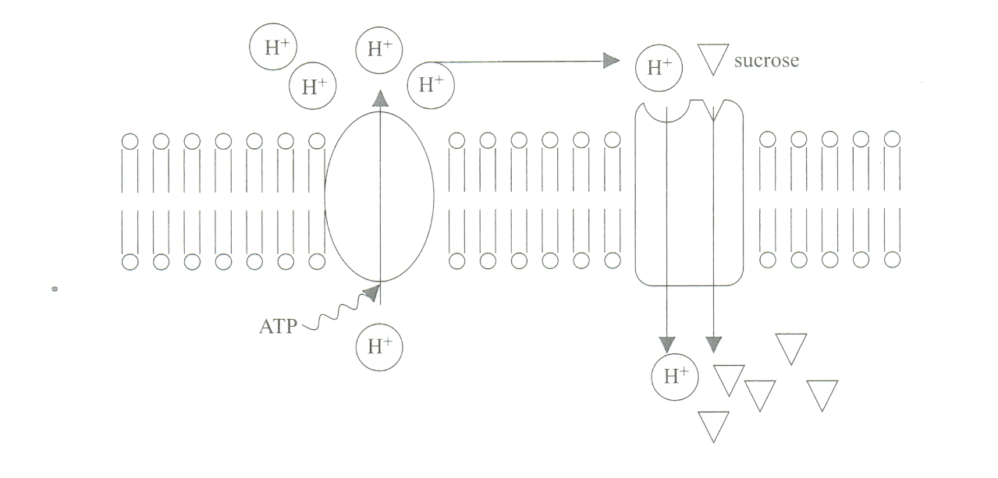
An ATP-driven pump concentrates H+ ions on the outside of the cell membrane.
The H+ ions then diffuse back into the cell, bringing sucrose molecules with them through special protein molecules in the membrane. The intracellular concentration of sucrose then increases.
Which one of the following changes would increase the rate of transport of sucrose into the cell?
- An increased extracellular concentration of H+
- A decreased intracellular concentration of ATP
- An increased intracellular concentration of sucrose.
- A decreased extracellular concentration of sucrose.
- Refer to the following diagram, which shows molecule A in a cell membrane, and structure B, which attaches a mitochondrion to the cell membrane. The diagram is not drawn to scale.
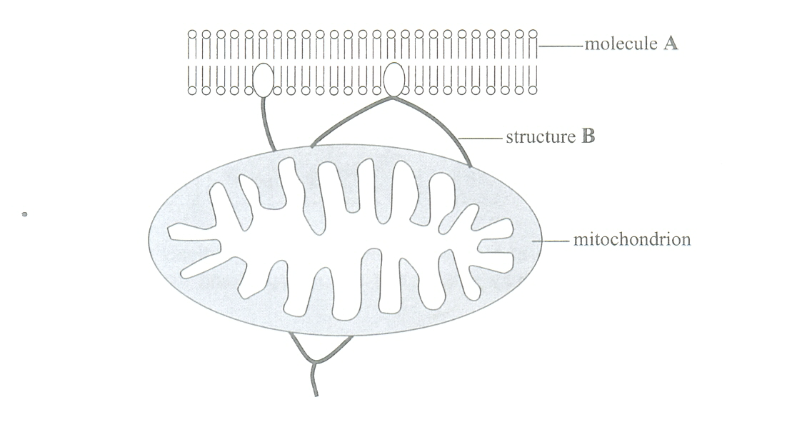
Which one of the following combinations correctly identifies molecule A and structure B in the diagram above?
 | Molecule A | Structure B
J | Protein | Endoplasmic reticulum
K | Protein | cytoskeleton
L | Phospholipid | Endoplasmic reticulum
M | phospholipid | cytoskeleton
- Refer to the following diagram, which shows molecules involved in a cellular process.
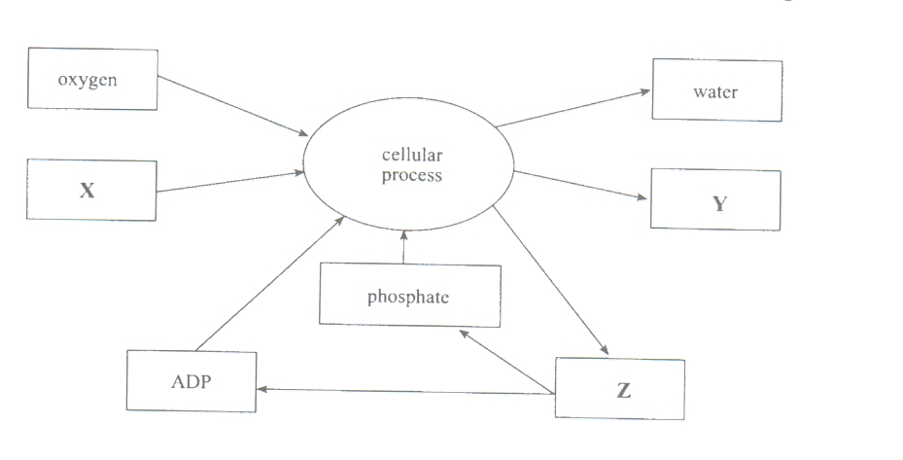
Which one of the following combinations correctly identifies the substances X,Y and Z?
 | X | Y | Z
J | Glucose | Carbon dioxide | ATP
K | Carbon dioxide | ATP | Glucose
L | Carbon dioxide | Glucose | ATP
M | Glucose | ATP | Carbon dioxide

- Refer to the following metabolic pathway, which occurs in cells. The addition of chemical X causes an accumulation of glucose-6-phosphate.
The most likely explanation for this accumulation is that X
- Catalyses the breakdown of glucose-6-plosphate.
- Is an inhibitor of enzyme 2
- Catalyses the breakdown of glucose-1-phosphate.
- Is an inhibitor of enzyme 3

Section B: Short Answer Please answer these questions in the spaces provided.
1. When examined under an electron microscope, a muscle cell seems to have many mitochondria. How do you account for this? [2 marks]

2. List 3 functions of the cytoskeleton. [3 marks]

3. State two pieces of evidence that support the idea that the first eukaryotic cells were formed by endosymbiosis. [4 marks]

4. Why is the current model of the cell membrane called the “Fluid Mosaic Model” and how does this explain the functions of the membrane. [4 marks]

  - State one reason why aerobic respiration must involve a series of small, regulated steps. [2 marks]

  - State why DNA needs to be replicated prior to mitotic cell division. [2 marks]

  - Refer to the following diagram, which shows a cell before a food particle is ingested by endocytosis and after endocytosis.
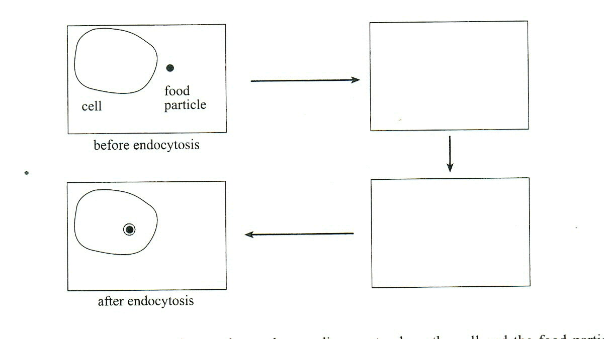
In each of the two empty boxes above, draw a diagram to show the cell and the food particle in progressive stages of endocytosis. [4marks]
  - Refer to the following diagrams, which show two successive states, I and II, in the division of a cell:
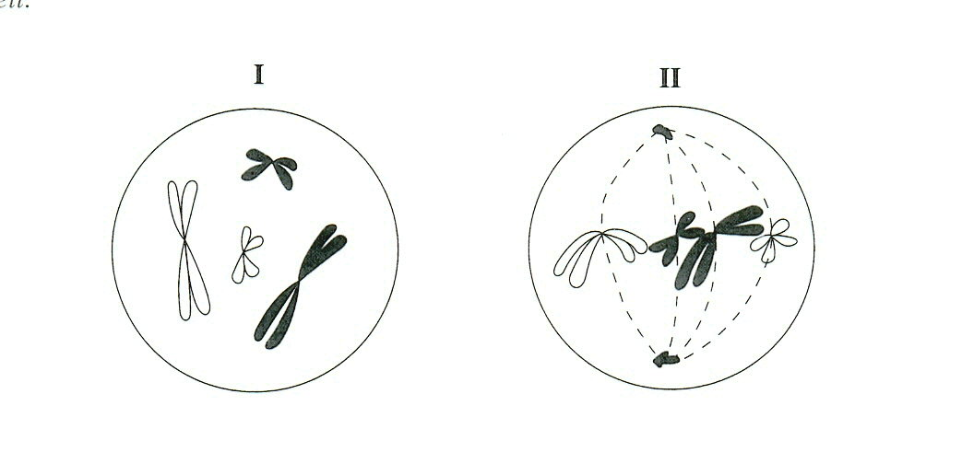
    - In the space below, draw the chromosomes as they would appear next (in stage III of the division of this cell).
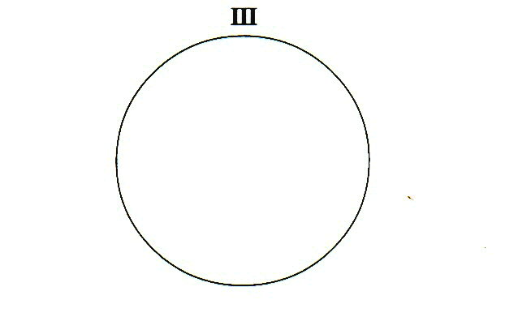 (2marks)
    - State one piece of evidence from the diagrams above to indicate that this is a eukaryotic cell. [2 marks]

    - Name the cell structure that moves the organelles and the cell membrane during cell division. [1 mark]

  - Refer to the following diagram, which shows some of the events in the cell cycle of eukaryotic cells:
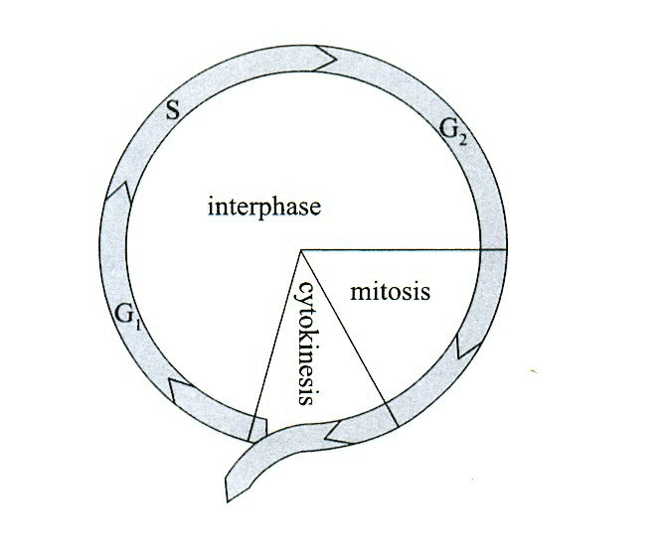
    - Compare the amount of DNA in a cell at G₂ with the amount of DNA in a cell at G₁.

    - Compare the genetic composition of the daughter cells produced by mitotic cell division with the genetic composition of the parent cell.

    - State one function of the cytoskeleton during mitotic cell division.
.
Refer to the following diagrams, which show the results of an experiment used to investigate the mutation rate of the bacterium Salmonella:
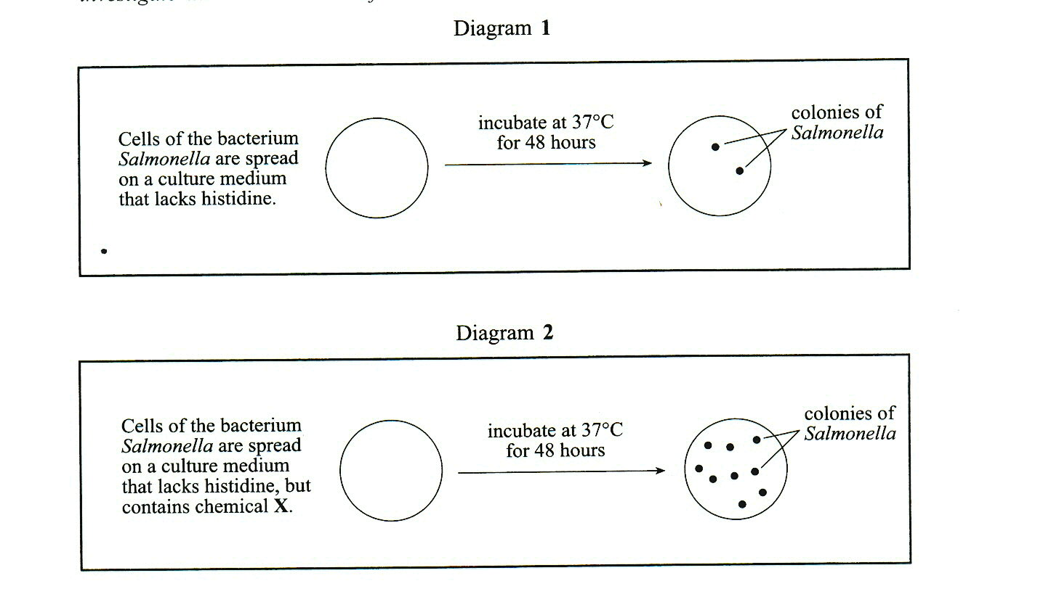
Salmonella is normally unable to synthesise the amino acid histidine and therefore does not grow on a culture medium that lacks histidine. The colonies of Salmonella that do grow on this medium have a mutation that enables the bacteria to synthesise histidine.
The first part of the experiment involved growing colonies of Salmonella on a culture medium that lacked histidine. The result of the first o the experiment is shown in diagram 1.
In the second part of the experiment, chemical X was mixed with the same culture medium. The result of this part of the experiment is shown in diagram 2.
  - State one possible hypothesis being tested in this experiment.

  - State the dependent variable in this experiment.

  - State one systematic error that could affect the results of this experiment.

  - State why it can be concluded that chemical Xis a mutagenic chemical.

  - Name two factors, other than mutagenic chemicals, that increase mutation rate.

Section D: Essay (30 mins) [15 Marks]
Choose one of the following only. Spend a little time planning the essay. Diagrams and equations. may assist your essay.
            - Human Beings in use chemicals and are surrounded by them everyday in our modern society. Discuss the biological effects that have resulted from the use of chemicals by human beings.
            - Discuss three beneficial effects.
            - Discuss three harmful effects.
- There is strong evidence for the common ancestry of all living things. Biologists believed that the evolution of eukaryotic cells from prokaryotic cells probably involved endosymbiotic events.
- Explain how the study of DNA provides strong evidence for the common ancestry of all living things.
- Describe differences in the internal structure of prokaryotic and eukaryotic cells
- Describe the process of endosymbiosis and provide one piece of evidence of the evolution of eukaryotic cells by endosymbiosis.
MULTIPLE CHOICE ANSWER SHEET
NAME.......................................................................................
Instructions
From the alternatives given in the questions, choose the one that is correct or best. Circle the corresponding letter on the answer sheet below. If you wish to change your answer, cross out your original choice and circle your new choice. Each question has only one correct answer.

- J K L M
- J K L M
- J K L M
- J K L M
- J K L M
- J K L M
- J K L M
- J K L M
- J K L M
- J K L M
- J K L M
- J K L M
- J K L M
- J K L M
- J K L M
- J K L M
- J K L M
- J K L M
- J K L M
- J K L M
- J K L M
- J K L M
- J K L M
- J K L M
- J K L M
- J K L M
- J K L M
- J K L M

