SECTION A: MULTIPLE-CHOICE QUESTIONS (Questions 1 to 14)
(28 marks)
Answer all questions in this section.
Each of the fifteen multiple-choice questions in Section A involves choosing from four alternative answers. Read each question carefully. Then indicate the one alternative that you consider best answers the question by shading the bubble by the appropriate letter alongside the question number on the multiple-choice answer sheet. Use black or blue pen. It is in your interest to give an answer to every question in this section of the paper, as no marks are deducted for incorrect answers. Each question is worth two marks. You should spend about 10 to 15 minutes on this section.

1. Refer to the following diagrams, which show the components of a nucleotide in a DNA molecule:
Which one of the following diagrams shows the arrangement of these components in a nucleotide that will pair in a DNA molecule with a nucleotide that contains guanine?

2. Translation on ribosomes involves decoding information carried on:
J. DNA
K. protein
L. mRNA
M. tRNA

3. Refer to the following sequence of bases, which was transcribed from a nucleic acid:
… A U A G C C C U A G G C …
Which one of the following sequences of bases is the template that was used for this transcription?

J. … U A U C G G G A U C C G …
K. … A T A G C C C T A G G C …
L. … T A T C G G G A T C C G …
M. … C G G A T C C C G A T A …

4. A length of DNA that codes for part of a polypeptide is known to contain 633 base pairs.
Which one of the following combinations of number of codons and number of amino acids in the polypeptide is most likely to be associated with this length of DNA?

5. Translation on ribosomes involves decoding information carried on:
J. DNA
K. protein
L. mRNA
M. tRNA

6. Which one of the following macromolecules is not used as an energy reserve in a cell?
J. Chitin.
K. Lipid.
L. Glycogen.
M. Starch.
7. Part of one chain of nucleotides in a DNA molecule carries the following sequence of bases.
TTATACATGGCATTATACGCAACC
How many amino acids did this sequence code for?
J. four
K. eight
L. twelve
M. twenty four

8. According to the induced-fit model for enzyme action, an enzyme changes shape
J. when it binds to its substrate.
K. and therefore it can work with many different substrates.
L. to be the same as the shape of its substrate.
M. to fit closely to the active site on the substrate.

9. Refer to the following diagram, which shows six DNA fingerprints: the DNA of a man, a woman, and the woman’s four children.

Which child is not the biological offspring of the man?
J. Child 1.
K. Child 2.
L. Child 3.
M. Child 4.

10. In the polymerase chain reaction (PCR), a solution containing DNA and an enzyme is repeatedly heated and cooled.
The solution is heated to
J. provide activation energy for the enzyme
K. denature the enzyme
L. break the weak bonds in the sugar- phosphate backbone of DNA.
M. break the weak bonds between the bases in DNA.
11. Refer to the following diagram, which shows the evolutionary relationships of different organisms. The diagram is based on the number of amino acid differences in cytochrome c proteins of those organisms.
source adapted from A Crierie & D. Greig, 1999, Biology: Key Ideas Essentials, Adelaide, p.36
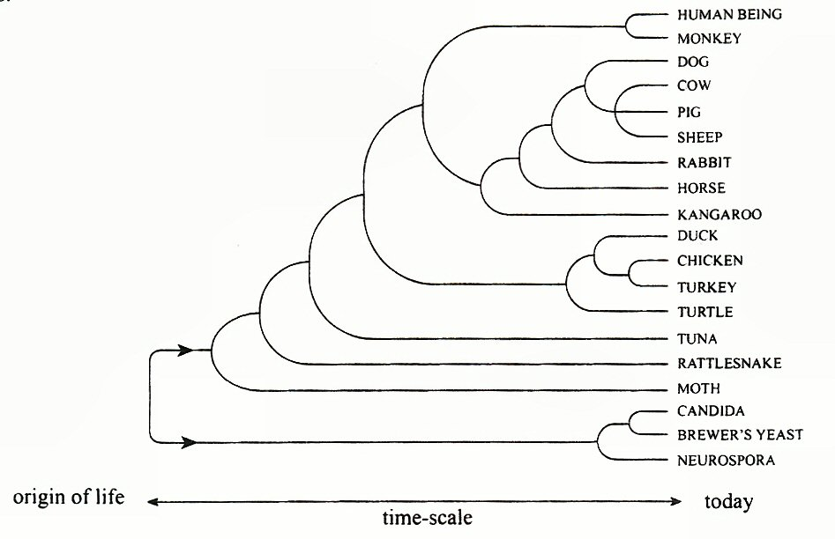
Which one of the following pairs of organisms would show the greatest similarity in DNA base sequences coding for cytochrome c?
  - Duck and turkey
  - Moth and tuna
  - Turtle and rattlesnake
  - Candida and brewer’s yeast
12. The enzyme cellulase is sometimes added to washing powders. Cellulase helps remove grass stains by breaking down cellulose into glucose. It has an optimum pH of 5.0 and an optimum temperature of 55ºC.
Which one of the following conditions would result in faster removal of grass stains from clothes being washed with a powder that contains cellulase?
J. Increasing the wash temperature from 55ºC to 60ºC.
K. Adding less than the optimum amount of washing powder to the wash
L. Decreasing the pH from 7.0 to 6.0
M. Adding more than the recommended amount of water to the wash.
13. Which one of the following compounds is a macromolecule that is used as an energy reserve in some plant tissues?
J. Glucose
K. Cellulose
L. Oil
M. Glycogen

14. Experiments were carried out to show the effects of pH and temperature on enzyme activity. The experiments also tested the effects of a chemical called an inhibitor. The results are shown in the graphs.

The best conclusion that can be drawn from these results is that the inhibitor affects
J. pH.
K. temperature.
L. enzyme activity.
M. enzyme concentration.

SECTION B: SHORT-ANSWER QUESTIONS (Questions 15 to 20)
(45 marks)
You should spend about 110 minutes on this section. Answers may be in note form. The allocation of marks is shown in brackets at the end of each part of each question. Answer all questions in the spaces provided.

15. Refer to the following diagram, which shows cellular process A:

(a) State the name of cellular process A (RNA protein). (1 mark)

(b) Describe the roles of mRNA and tRNA in the process of protein synthesis in eukaryotic cells. (4 marks)

mRNA:

tRNA:

16. Refer to the following diagram that represents the flow of information from DNA to a polypeptide.
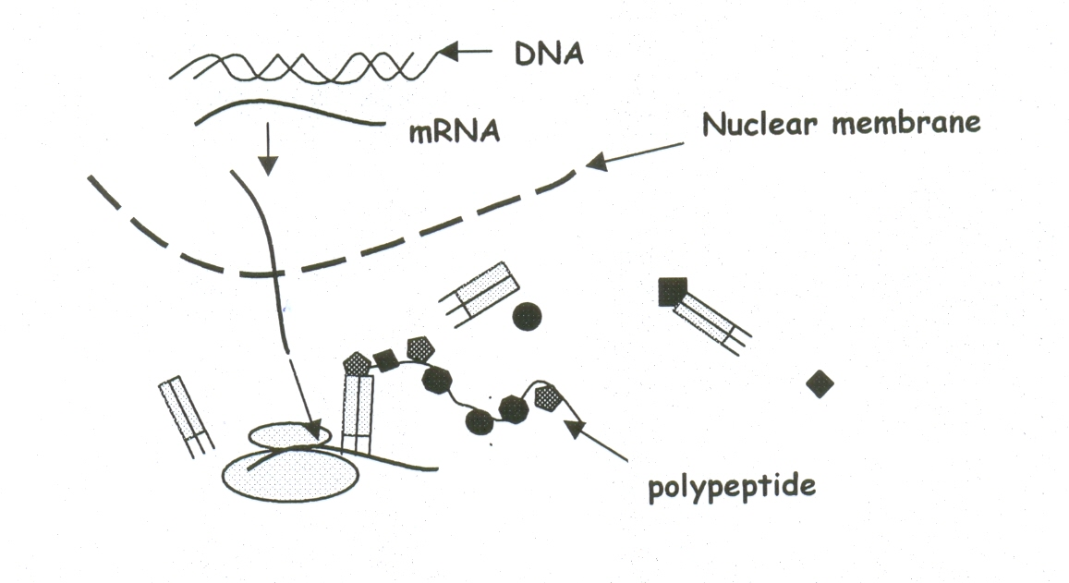
(a) On the diagram, label a tRNA molecule. (2 mark)
(b) Name the process and describe how the mRNA molecule is made.
Process: (2 mark)

Description: (4 marks)

17. Use the diagram below to answer the following questions.
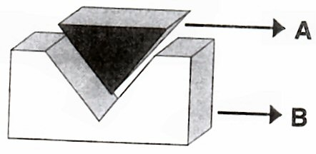
(a) What do the molecules A and B represent in the above diagram?
A_____________________________________________________(1 mark)
B_____________________________________________________(1 mark)

(b) Explain the meaning of the term active site and colour the region on the diagram. (2 marks)

18. Refer to the following diagram, which shows four stages in a type of cell division.
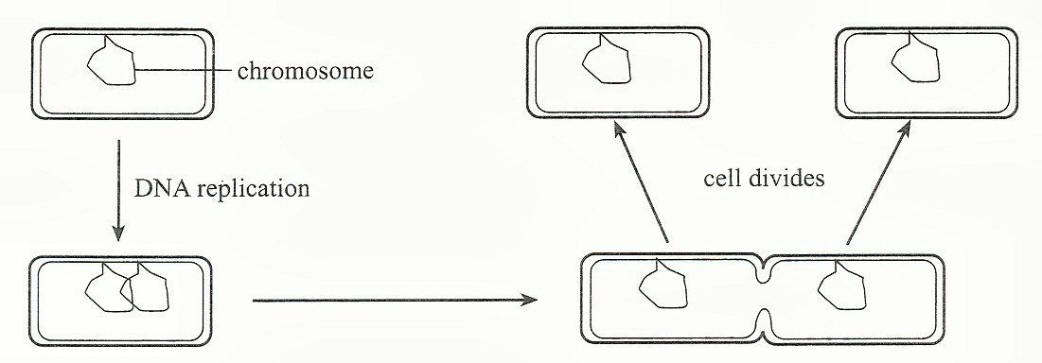
(a) State why DNA replication occurs before the cell divides. (2 marks)

(b) Describe the process of DNA replication. (4 marks)

(c) Why is the replication of DNA called semi-conservative? (2 marks)

(d) Explain the differences between DNA, genes and chromosomes.(4 marks)

19. Ecowash BB and Addcool are commercially produced enzymes. Ecowash BB is used to pre-fade denim, whereas Addcool ‘polishes’ fibres and improves the durability of the fabric.
The effectiveness of each of these enzymes on its own substrate was tested at a range of temperatures. For each enzyme, ten test tubes were set up. Each test tube contained 30 millilitres of the substrate and 2 millilitres of the same concentration of enzyme. Each test tube was held at a constant temperature. After 20 minutes the reaction mixture was tested and the percentage of the original quantity of substrate that remained was recorded. The results of this experiment are shown in the table below:
(a) Graph the data for Ecowash BB and for Addcool on one set of axes on the grid below. Label each graph. (4 marks)

(b) State the independent variable in this experiment. (2 mark)

(c) State a conclusion that is consistent with the data in the table. (2 mark)

(d) State why the enzymes are ineffective at:
(i) 5°C. (2 mark)

(ii) 95°C. (2 mark)

(e) State the temperature at which Addcool is 99% effective in this experiment.
__________°C. (2 mark)
20. Banana plants can be genetically engineered to synthesise a vaccine against the hepatitis B virus. The process involves transferring selected genes from the virus into cells in the banana plant.
(a) Describe one method of transferring the selected genes from the hepatitis B virus into cells in the banana plant. (4 marks)

(b) The genetically engineered banana plant is of benefit to human beings. Describe one other example of how genetic engineering is used to produce an organism of benefit to human beings. (4 marks)

(c) Some people argue that genetic engineering should be banned or restricted. Describe one argument against the use of genetic engineering in plants AND one argument against the use of genetic engineering in animals.
(4 marks)

SECTION C: EXTENDED-RESPONSE QUESTIONS (Question 21)
(15 marks)

You should spend about 15 to 20 minutes on this section, 5 minutes planning and 10 to 15 minutes writing. Credit will be given for clear, well-expressed answers that are well organised and relevant to the question.

22. Analysing a ‘DNA fingerprint’ has become increasingly important during forensic investigations.
- Describe the steps involved in creating a DNA fingerprint.
- The Polymerase Chain Reaction (PCR) is important in the process. Describe PCR and how it is utilised by forensic investigators.
- Some suggest that the police should have access to every citizen’s DNA fingerprint on a database. Discuss the pros and cons of having a DNA database.
15 marks

