SECTION A: MULTIPLE-CHOICE QUESTIONS (Questions 1 to 14)
(28 marks)
Answer all questions in this section.
Each of the fifteen multiple-choice questions in Section A involves choosing from four alternative answers. Read each question carefully. Then indicate the one alternative that you consider best answers the question by shading the bubble by the appropriate letter alongside the question number on the multiple-choice answer sheet. Use black or blue pen. It is in your interest to give an answer to every question in this section of the paper, as no marks are deducted for incorrect answers. Each question is worth two marks. You should spend about 10 to 15 minutes on this section.

1. Refer to the following diagrams, which show the components of a nucleotide in a DNA molecule:
Which one of the following diagrams shows the arrangement of these components in a nucleotide that will pair in a DNA molecule with a nucleotide that contains guanine?

Answer: K

2. Translation on ribosomes involves decoding information carried on:
J. DNA
K. protein
L. mRNA
M. tRNA

3. Refer to the following sequence of bases, which was transcribed from a nucleic acid:
… A U A G C C C U A G G C …
Which one of the following sequences of bases is the template that was used for this transcription?

J. … U A U C G G G A U C C G …
K. … A T A G C C C T A G G C …
L. … T A T C G G G A T C C G …
M. … C G G A T C C C G A T A …

4. A length of DNA that codes for part of a polypeptide is known to contain 633 base pairs.
Which one of the following combinations of number of codons and number of amino acids in the polypeptide is most likely to be associated with this length of DNA?
Answer: M

5. Translation on ribosomes involves decoding information carried on:
J. DNA
K. protein
L. mRNA
M. tRNA

6. Which one of the following macromolecules is not used as an energy reserve in a cell?
J. Chitin.
K. Lipid.
L. Glycogen.
M. Starch.
7. Part of one chain of nucleotides in a DNA molecule carries the following sequence of bases.
TTATACATGGCATTATACGCAACC
How many amino acids did this sequence code for?
J. four
K. eight
L. twelve
M. twenty four

8. According to the induced-fit model for enzyme action, an enzyme changes shape
J. when it binds to its substrate.
K. and therefore it can work with many different substrates.
L. to be the same as the shape of its substrate.
M. to fit closely to the active site on the substrate.

9. Refer to the following diagram, which shows six DNA fingerprints: the DNA of a man, a woman, and the woman’s four children.

Which child is not the biological offspring of the man?
J. Child 1.
K. Child 2.
L. Child 3.
M. Child 4.

10. In the polymerase chain reaction (PCR), a solution containing DNA and an enzyme is repeatedly heated and cooled.
The solution is heated to
J. provide activation energy for the enzyme
K. denature the enzyme
L. break the weak bonds in the sugar- phosphate backbone of DNA.
M. break the weak bonds between the bases in DNA.
11. Refer to the following diagram, which shows the evolutionary relationships of different organisms. The diagram is based on the number of amino acid differences in cytochrome c proteins of those organisms.
source adapted from A Crierie & D. Greig, 1999, Biology: Key Ideas Essentials, Adelaide, p.36
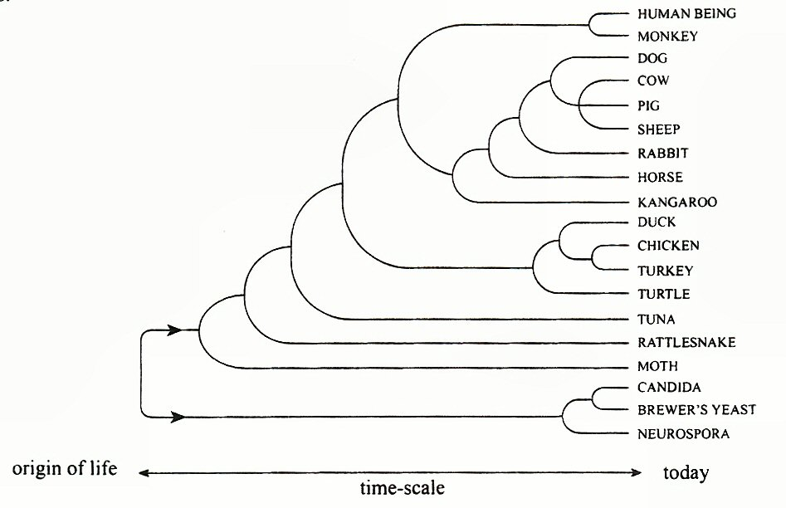
Which one of the following pairs of organisms would show the greatest similarity in DNA base sequences coding for cytochrome c?
  - Duck and turkey
  - Moth and tuna
  - Turtle and rattlesnake
  - Candida and brewer’s yeast
12. The enzyme cellulase is sometimes added to washing powders. Cellulase helps remove grass stains by breaking down cellulose into glucose. It has an optimum pH of 5.0 and an optimum temperature of 55ºC.
Which one of the following conditions would result in faster removal of grass stains from clothes being washed with a powder that contains cellulase?
J. Increasing the wash temperature from 55ºC to 60ºC.
K. Adding less than the optimum amount of washing powder to the wash
L. Decreasing the pH from 7.0 to 6.0
M. Adding more than the recommended amount of water to the wash.
13. Which one of the following compounds is a macromolecule that is used as an energy reserve in some plant tissues?
J. Glucose
K. Cellulose
L. Oil
M. Glycogen

14. Experiments were carried out to show the effects of pH and temperature on enzyme activity. The experiments also tested the effects of a chemical called an inhibitor. The results are shown in the graphs.

The best conclusion that can be drawn from these results is that the inhibitor affects
J. pH.
K. temperature.
L. enzyme activity.
M. enzyme concentration.

SECTION B: SHORT-ANSWER QUESTIONS (Questions 16 to 21)
(45 marks)
You should spend about 110 minutes on this section. Answers may be in note form. The allocation of marks is shown in brackets at the end of each part of each question. Answer all questions in the spaces provided.

15. Refer to the following diagram, which shows cellular process A:

(a) State the name of cellular process A (RNA protein). (1 mark)
Translation

(b) Describe the roles of mRNA and tRNA in the process of protein synthesis in eukaryotic cells. (4 marks)

mRNA:
Copies the base sequence from the DNA and takes this copy to the ribosomes to be translated by tRNA.

tRNA:
Translates the genetic code from mRNA and collects Amino acids that correspond to this code. These Amino Acids are built into a polypeptide chain.

16. Refer to the following diagram that represents the flow of information from DNA to a polypeptide.
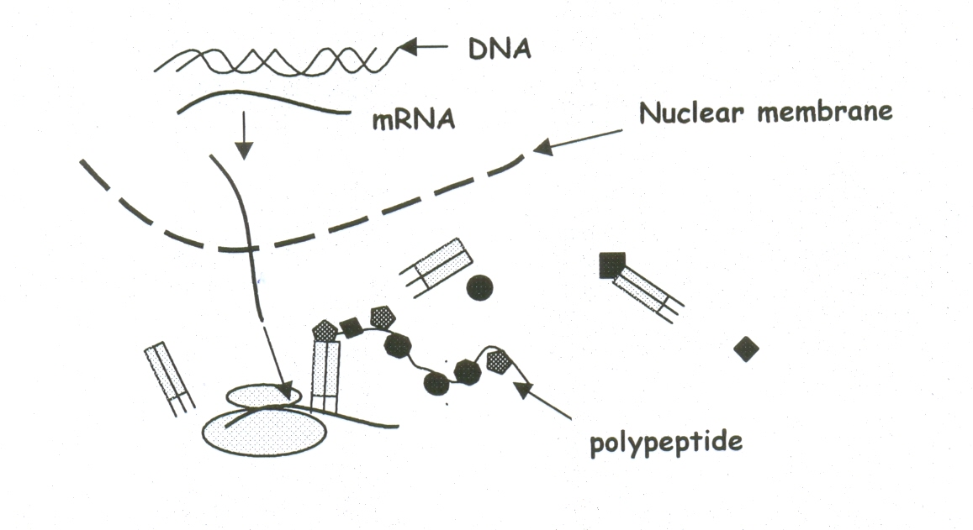
(a) On the diagram, label a tRNA molecule. (2 mark)
(b) Name the process and describe how the mRNA molecule is made.
Process: (2 mark)
Transcription

Description: (4 marks)
An enzyme “unzips” the DNA double helix and loose nucleotides read the genetic code (with Uracyl replacing Thymine). The nucleotides are attached together by an enzyme which creates a mRNA molecule.

17. Use the diagram below to answer the following questions.
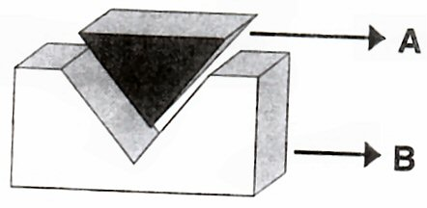
(a) What do the molecules A and B represent in the above diagram?
A__Substrate___________________________________________(1 mark)
B__Enzyme____________________________________________(1 mark)

(b) Explain the meaning of the term active site and colour the region on the diagram. (2 marks)
The active site is where the substrate bonds with the enzyme and the activation energy required for cell processes is reduced.

18. Refer to the following diagram, which shows four stages in a type of cell division.
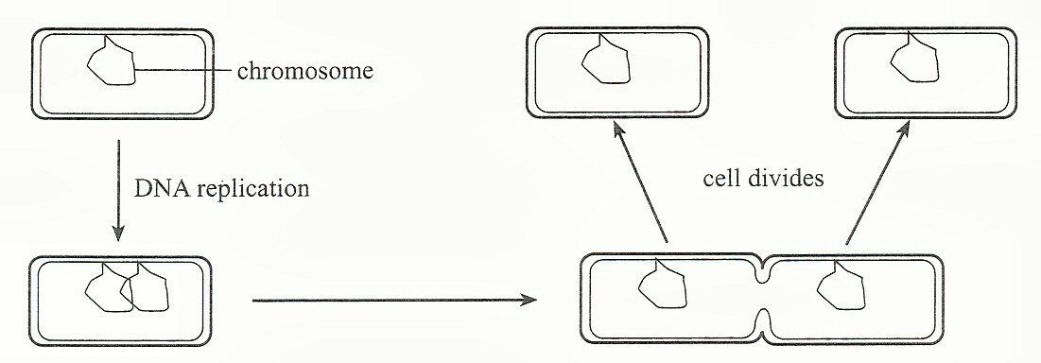
(a) State why DNA replication occurs before the cell divides. (2 marks)
To ensure that there is enough genetic material in both of the new cells (46 chromosomes).

(b) Describe the process of DNA replication. (4 marks)
An enzyme “unzips” the DNA molecule and loose nucleotides line up with their base pair. An enzyme then attaches the nucleotides together to make 2 double helix molecules. Each new molecule will have one old strand and one new strand.

(c) Why is the replication of DNA called semi-conservative? (2 marks)
Each new molecule will have one old strand and one new strand.

(d) Explain the differences between DNA, genes and chromosomes.(4 marks)
Chromosomes are found in the nucleus of Eukaryotic cells (humans have 46). DNA is found as double helix molecules on these chromosomes and there are many genes on a DNA molecule. Genes are the genetic code of an organism and include the specific base sequences.

19. Ecowash BB and Addcool are commercially produced enzymes. Ecowash BB is used to pre-fade denim, whereas Addcool ‘polishes’ fibres and improves the durability of the fabric.
The effectiveness of each of these enzymes on its own substrate was tested at a range of temperatures. For each enzyme, ten test tubes were set up. Each test tube contained 30 millilitres of the substrate and 2 millilitres of the same concentration of enzyme. Each test tube was held at a constant temperature. After 20 minutes the reaction mixture was tested and the percentage of the original quantity of substrate that remained was recorded. The results of this experiment are shown in the table below:
(a) Graph the data for Ecowash BB and for Addcool on one set of axes on the grid below. Label each graph. (4 marks)

(b) State the independent variable in this experiment. (2 mark)
The temperature

(c) State a conclusion that is consistent with the data in the table. (2 mark)
If the temperature is increased, then the percentage of substrate remaining will decrease until the enzyme is denatured.

(d) State why the enzymes are ineffective at:
(i) 5°C. (2 mark)
The activation energy is too low and the enzyme cannot work.

(ii) 95°C. (2 mark)
The enzyme has been denatured and the active site is destroyed.

(e) State the temperature at which Addcool is 99% effective in this experiment.
35__________°C. (2 mark)
20. Banana plants can be genetically engineered to synthesise a vaccine against the hepatitis B virus. The process involves transferring selected genes from the virus into cells in the banana plant.
(a) Describe one method of transferring the selected genes from the hepatitis B virus into cells in the banana plant. (4 marks)
Locate the gene of interest with a gene probe and remove the gene using a restriction enzyme. Remove the plasmid from bacteria and insert the plasmid gene of interest into the plasmid. Place the plasmid and gene into the bacteria cell to continue to multiply. Remove the gene of interest and insert it into the nucleus of the banana plant.

(b) The genetically engineered banana plant is of benefit to human beings. Describe one other example of how genetic engineering is used to produce an organism of benefit to human beings. (4 marks)
Potatoes given to poverty stricken nations have been modified to include cholera vaccines. By inserting a series of genes into the potato cells, this variant of potato can help to immunize poorer populations of cholera.

(c) Some people argue that genetic engineering should be banned or restricted. Describe one argument against the use of genetic engineering in plants AND one argument against the use of genetic engineering in animals.
(4 marks)

Genetically modified plants can reduce the biodiversity of a region by spreading to neighbouring regions and cross-pollinating with native plants. This can effect species diversity and the ecosystem as a whole.

Genetically modified animals can be considered as ethically wrong because animals can be harmed or fatally damaged due to the modifications. Mutations in the DNA can occur and this can seriously effect the organisms.

SECTION C: EXTENDED-RESPONSE QUESTIONS (Question 21)
(15 marks)

You should spend about 15 to 20 minutes on this section, 5 minutes planning and 10 to 15 minutes writing. Credit will be given for clear, well-expressed answers that are well organised and relevant to the question.

21. Analysing a ‘DNA fingerprint’ has become increasingly important during forensic investigations.
- Describe the steps involved in creating a DNA fingerprint.
- The Polymerase Chain Reaction (PCR) is important in the process. Describe PCR and how it is utilised by forensic investigators.
- Some suggest that the police should have access to every citizen’s DNA fingerprint on a database. Discuss the pros and cons of having a DNA database.
15 marks
One method of creating a DNA fingerprint is using electrophoresis. Firstly the DNA is extracted from a cell and restriction enzymes are used to cut up the DNA into fragments. These fragments are then separated by electrophoresis. The fragments are then heated to separate the bonds between the bases in the double stranded DNA. This creates two single strands of DNA. Transfer the DNA fragments from the gel to nylon and add radioactive probes. Finally transfer the fragments onto photographic film.
PCR is a fast and inexpensive method of making many copies of a section of DNA. This helps forensic scientists to amplify the amount of DNA they are testing. Without this method of copying DNA, testing would be a difficult task.
There are strong similarities shown between the DNA of children and parents therefore a DNA database is a useful tool for paternity tests. DNA fingerprints can also be useful for identifying criminals by forensic scientists. With a DNA database, the courts could convict more criminals accurately using the DNA evidence. DNA profiling can also be used to identify inherited disorders and perhaps create cures for these mutations. The negative impacts of a DNA database include the loss of individual’s rights to choose what information is accessed by police and the government. This genetic information could be misused and many people do not want anyone to have access to their genetic information. It is also debatable whether the DNA profile is accurate because of human error. People reading the profile may misunderstand the information.

