Section |  | Max  126 | Marks Obtained
A | 40
B | 56
C | 30
Total
% Grade
2014 Biology

Birdwood High School
2014 Biology
Semester 1 Exam
Time: 2 hours

NAME:__________________________ SACE REG. No.: ___________________________

Dictionaries and calculators approved by SACE may be used subject to SACE regulations.

Instructions to Candidates
1. You will have 10 minutes to read the paper. You must not write in your question booklets, or on your multiple choice answer sheet, or use your calculator during this reading time but you may make notes on the scribbling paper provided.

2. This paper contains three sections: Section A, Section B, Section C.

3. The allocation of marks and suggested allotment of time are as follows:
Section A 40 marks 30 minutes
Section B 56 marks 60 minutes
Section C 30 marks 30 minutes
Total 126 marks 2 hours

4. At the end of the examination, place the multiple-choice answer sheet inside the question booklet.
Section A: Multiple Choice Questions
Circle the correct letter on the multiple choice response sheet.

1. Carcinogens are chemicals that
J. increase the rate of cell division by causing harmful mutations.
K. decrease the rate of cell division by causing beneficial mutations.
L. increase the rate of cell division by causing beneficial mutations.
M. decrease the rate of cell division by causing harmful mutations.

2. Which statement about macromolecules is FALSE?
J. Both DNA and RNA are polymers of nucleotides.
K. A monosaccharide is a long-chain polymer formed of simple sugars.
L. Both cellulose and starch are polymers of glucose.
M. Triglycerides (or simple lipids) contain fatty acids and glycerol.

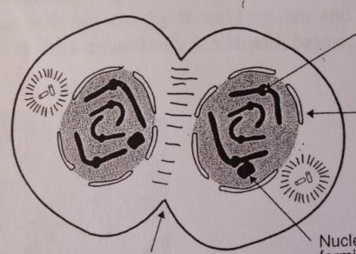
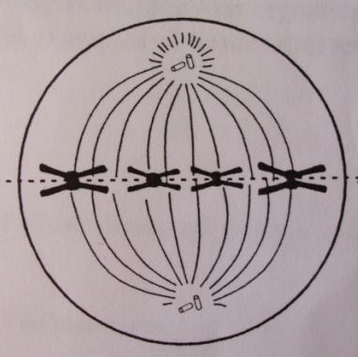
Use the following diagrams, showing stages of cell division (in no particular order), labeled A, B and C to answer questions 3 and 4.
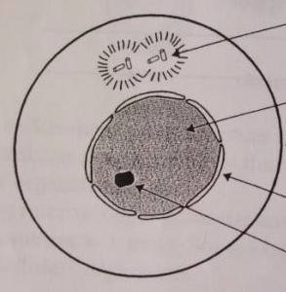
A B C

3. The correct order of division is:
J. A B C
K. C B A
L. B C A
M. B A C

4. Stage B is called:
J. Interphase.
K. Metaphase.
L. Telophase.
M. Anaphase.

5. When mitosis has ended, the number of chromosomes in a daughter cell is:
J. Equal to the number in a mother cell.
K. Double the number in the mother cell.
L. Half the number in the mother cell.
M. Unrelated to the number in the mother cell.

6. In a plant cell, which of the following is correct for a cellular process, where it occurs and what is produced?
 | Cellular Process | Location in the Cell | Product
J. | Respiration | Mitochondria | Carbon Dioxide
K. | Photosynthesis | Mitochondria | Oxygen
L. | Respiration | Nucleus | Messenger RNA
M. | Respiration | Chloroplast | Oxygen

The next two questions refer to the diagram on the right.
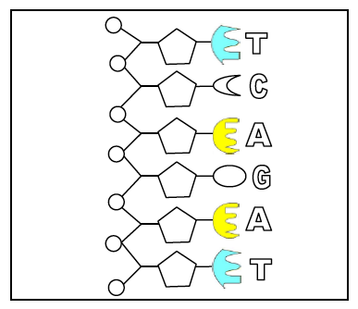
7. The diagram represents a portion of:
J. mRNA
K. tRNA
L. DNA
M. Protein

8. The correct sequence of lettered parts in the complementary strand of this molecule is:
J. TAGACT
K. AGTCTA
L. TCAGAT
M. GACTCG

9. DNA fingerprinting has become a familiar forensic tool and has been cited in recent criminal trials. It is possible to do DNA fingerprinting with even a minute sample of DNA because:
J. DNA contains only four different types of nitrogenous bases.
K. There are large quantities of DNA in each cell of the body.
L. DNA determines a very specific polypeptide chain.
M. The polymerase chain reaction can be used.

10. Enzymes will usually react with only one substance. This can be explained by the “lock and key” theory. If this theory is correct, which of the following substances, represented by J, K, L and M, would be acted on by enzyme A?

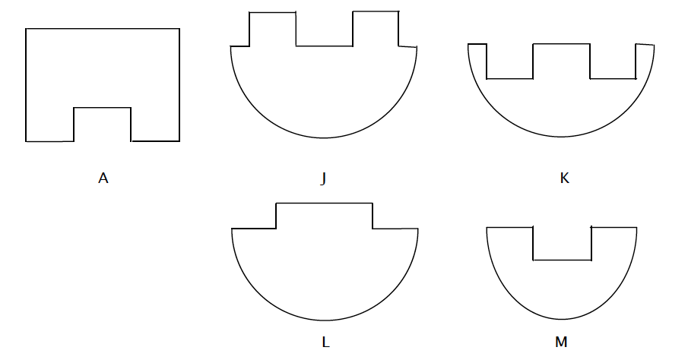
11. William and Mary are brother and sister and they are twins.
Ignoring mutations, which one of the following cells is genetically identical to a liver cell from William?
J. A liver cell from Mary.
K. A sperm cell from William.
L. A muscle cell from William.
M. An egg cell from Mary.

12. Cells with a concentration of 0.2% glucose inside were placed in a solution of 0.9% glucose. The cells would most probably:
J. Burst due to diffusion of glucose in.
K. Shrivel due to the osmotic movement of water out of the cell.
L. Shrivel due to diffusion of glucose out.
M. Burst due to the osmotic movement of water into the cell.

13. Thyroxine is a hormone that is involved in the regulation of body temperature in human beings.
Which one of the following responses will result from an increase in body temperature?
J. An increased release of thyroxine, resulting in a decreased cell metabolism.
K. A decreased release of thyroxine, resulting in a decreased cell metabolism.
L. A decreased release of thyroxine, resulting in an increased cell metabolism.
M. An increased release of thyroxine, resulting in an increased cell metabolism.

14. When the nucleus is removed from an Amoeba and replaced within two days the cell survives. If it is not replaced the cell dies. Which of the following statements best explains these results?
J. The nucleus is the major site of energy production in the cell.
K. The nucleus contains DNA which controls cell division.
L. The nucleus supplies information which is necessary for enzyme synthesis in the cell.
M. The nucleus is the major site of protein synthesis in the cell.

15. Semi-conservative replication of DNA occurs:
J. As part of protein synthesis.
K. Before mitosis.
L. Only in sperm and egg cells.
M. In the cytoplasm of cells.

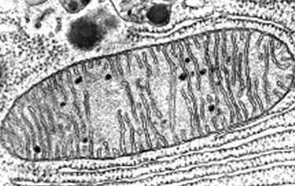
16. Refer to the following photomicrograph, which shows an organelle from a cell in a multicellular organism.
This organelle is the site of:
J. starch formation.
K. photosynthesis.
L. ATP synthesis.
M. glycogen storage.

17. The synthesis of protein within the cell involves:
J. The attachment of a molecule of DNA to the surface of the ribosome.
K. The attachment of a molecule of messenger RNA to an amino acid molecule.
L. The attachment of a molecule of amino acid to a molecule of transfer RNA.
M. The attachment of a molecule of DNA to a molecule of amino acid.

18. Using genetically engineered bacteria to produce insulin does NOT involve the following processes:
J. Transferring the ability to produce a new protein to the bacteria.
K. Inserting a recombinant plasmid into a bacterial cell.
L. Extracting the recombinant plasmids from the bacterial cell to get copies of the desired gene.
M. Using restriction enzymes to cut the DNA exposing the sticky ends in the cut DNA.

19. What would NOT be an expected consequence of changing one amino acid in a given protein?
J. The primary structure would be changed.
K. The tertiary structure would remain unchanged.
L. The biological activity of this protein might be altered.
M. The number of amino acids present would stay the same.

20. A length of DNA that codes for part of a polypeptide is known to contain 633 base pairs. Which one of the following combinations of number of codons and number of amino acids in the polypeptide is most likely to be associated with this length of DNA?
 | Number of codons | Number of amino acids in the polypeptide
J. | 1266 | 422
K. | 633 | 211
L. | 422 | 422
M. | 211 | 211

Section B: Short Answer Questions
Answer each questions giving as much detail as necessary.
1. Explain the meaning of the statement “the cell membrane is a dynamic structure.”
___________________________________________________________________________________
__________________________________________________________________________________
___________________________________________________________________________________
__________________________________________________________________________________
(3 marks)

2. The following diagram shows a cell that has been viewed through a microscope.
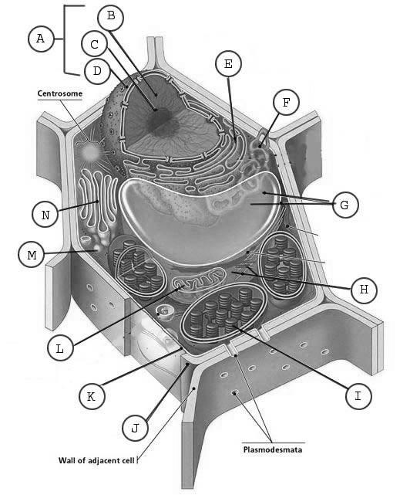

Answer the following questions that relate to the diagram above.
a) State whether it is plant or an animal cell and give a reason for your answer.
___________________________________________________________________________________
__________________________________________________________________________________
(3 marks)

b) Name a cellular organelle that you can see clearly and state its function.
___________________________________________________________________________________
__________________________________________________________________________________
___________________________________________________________________________________
__________________________________________________________________________________
(2 marks)

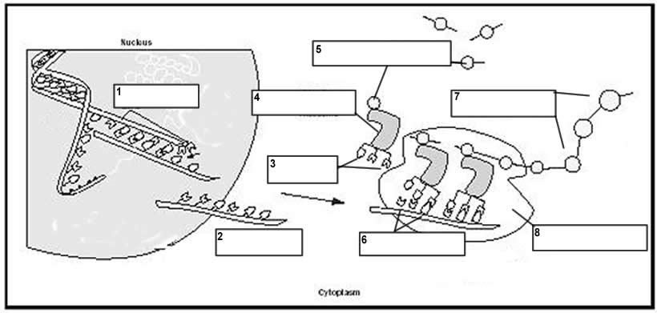

3. Refer to the following diagram, which shows various molecules and processes, which occurs during protein synthesis.

a) Name the process at 1.
___________________________________________________________________________________
(1 mark)
b) Name:
Molecule 2 ___________________________________________________________________________________
Molecule 3 ___________________________________________________________________________________
Molecule 7
___________________________________________________________________________________
(3 marks)
b) State one function of tRNA in protein synthesis. ___________________________________________________________________________________
___________________________________________________________________________________
(2 marks)
4. Many reactions occur owing to the presence of specific enzymes.
a) What feature of the structure of an enzyme results in its specificity? (A labeled diagram might help).

___________________________________________________________________________________
___________________________________________________________________________________
___________________________________________________________________________________
(4 marks)
b) How does a change in the acidity of a cell affect the activity of an enzyme?

___________________________________________________________________________________
___________________________________________________________________________________
___________________________________________________________________________________
___________________________________________________________________________________
(2 marks)

5. Certain deep-sea fish have a lux gene that causes some parts of their bodies to glow in the dark. Genetic engineers are attempting to produce trees that glow in the dark. These trees could be used for living Christmas trees or for street lighting.

a) Name the factor that would have to be transferred from the cells of one of these deep-sea fish to the cells of a tree to make the tree glow in the dark.
___________________________________________________________________________________
(2 marks)

b) Several techniques can be used to transfer the factor from the cells of the deep-sea fish to the cells of a tree. One technique is to coat tiny particles of gold or tungsten with the factor and then to shoot them into the cells of the tree. The treated cells can then be grown into trees. It is expected that fewer than 10% of these trees will glow in the dark.
State one reason why such a small percentage of the trees would be expected to glow in the dark. ___________________________________________________________________________________
___________________________________________________________________________________
___________________________________________________________________________________
(2 marks)

7. Respiration and photosynthesis are both processes that are involved in the energy cycle of the cell.
a) Write out the balanced equation of photosynthesis.

___________________________________________________________________________________
(4 marks)
b) State one reason why aerobic respiration and photosynthesis must involve a series of small-regulated steps.

___________________________________________________________________________________
___________________________________________________________________________________
(2 marks)

c) In the diagram below, indicate the letters that refer to:
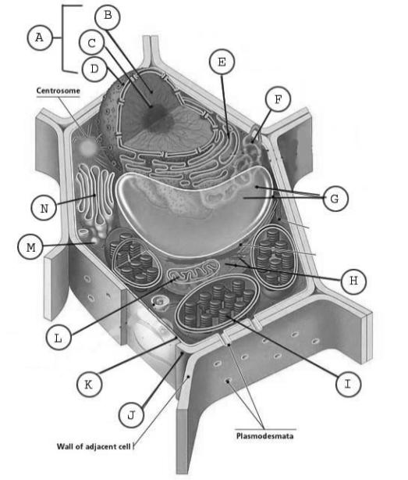
i) The site of the organelle where part of aerobic respiration occurs.
_______________________________________________________________________________
(1 mark)
ii) The site of transcription in the cell.

_______________________________________________________________________________
(1 mark)

8. Human beings use genetic engineering to modify foods.
State one advantage and one disadvantage that arise from the genetic modification of foods by human beings.
Advantage: ___________________________________________________________________________________
___________________________________________________________________________________
___________________________________________________________________________________
___________________________________________________________________________________
Disadvantage: ___________________________________________________________________________________
___________________________________________________________________________________
___________________________________________________________________________________
___________________________________________________________________________________
(4 marks)
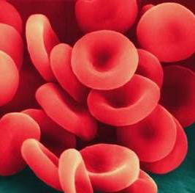
12. Explain why red blood cells have a particular biconcave shape by referring to their surface area to volume ratio and diffusion.
__________________________________________________
__________________________________________________
__________________________________________________ __________________________________________________ __________________________________________________ __________________________________________________ __________________________________________________ __________________________________________________ ___________________________________________________________________________________
___________________________________________________________________________________
(3 marks)
13. a) If the following is a segment of DNA showing its base sequence, write down the sequence that would be present in a molecule of messenger RNA that it would be used to make.
A T G C C T T A G G C A A T C C C C A T A
___________________________________________________________________________________
(2 marks)
b) How many codons are present and hence how many amino acids would be present in the polypeptide chains that this segment would code for? ___________________________________________________________________________________
___________________________________________________________________________________
(1 mark)

14. Cyanide is an inhibitor of the enzyme cytochrome oxidase, an enzyme vital to aerobic respiration.
a) State one way cyanide could inhibit the functioning of cytochrome oxidase.

___________________________________________________________________________________
___________________________________________________________________________________
___________________________________________________________________________________
___________________________________________________________________________________
(2 marks)
b) Explain why the addition of cyanide would reduce the amount of ATP production in a cell.

___________________________________________________________________________________
___________________________________________________________________________________
___________________________________________________________________________________
___________________________________________________________________________________
(2 marks)

c) Name one cell activity besides respiration that would be altered as a result of the action of cyanide.
___________________________________________________________________________________
(1 mark)
d) Why is it that enzymes are very effective even though they are only present in small quantities in cells?

___________________________________________________________________________________
___________________________________________________________________________________
(2 marks)

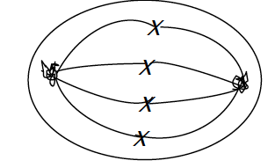
16. The adjacent diagram represents a microscopic view of a eukaryotic cell during mitosis.
a) List the four stages of mitosis.
___________ ___________ ____________ ___________
(1 mark)
b) Identify the stage, which the cell has reached.
________________________
(1 mark)
c) What happens to the chromosomal DNA during interphase? ______________________________________________________________________________________________________________________________________________________
(1 mark)

20. Proteins can be viewed as a progression of shapes. Explain each stage in the formation of a protein and what this means about the final shape of the protein.
_____________________________________________________________________________________________________________________________________________________________________________________________________________________________________________________________________________________________________________________________________________________________________________________________________________________________________________________________________________________________________________________________________________
(4 marks)
Section D: Extended Response
Answer 2 of the 3 questions in this section.
Write your answer on the script pages following. Begin each answer on a new page.
You should spend about 30 minutes on this section, 5 to 10 minutes planning and 20 to 25 minutes writing.
Credits will be given for clear, well-expressed answers that are well organised and relevant to the questions.

1. The cell membrane controls the movement of substances into and out of cells.
a) Describe the structure of the cell membrane;
b) Discuss the role of the membrane in both the active and passive movement of molecules.
(15 arks)

2. Human beings can manipulate DNA.
a) Describe how genetic manipulation is used to obtain protein products, such as human insulin, from bacteria.
b) Discuss one benefit of this application of genetic engineering and one problem it may cause.
(15 arks)

3. Cancer was the second most common cause of death in 2007, accounting for approximately three of every ten deaths. Cancer is caused by mutations.
a) Identify and explain one type of mutation and how it can affect cell metabolism.
b) Explain how a mutation in one cell causes a cancerous cell and then the development into cancerous tissue.
(15 marks)

